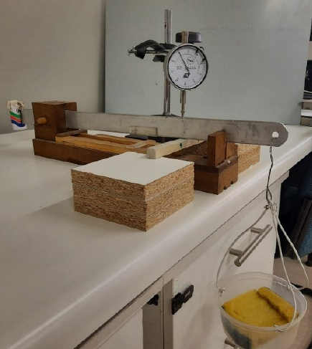 | Mortar beam simply supported on two wooden supports with counterbalanced beam and dial gauge
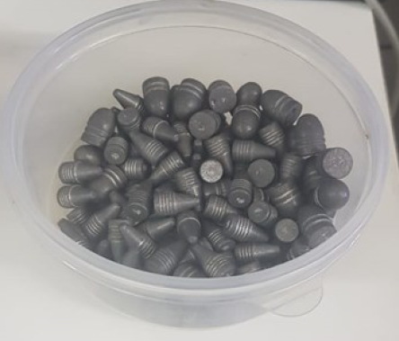 | Weights added to the counterbalanced beam
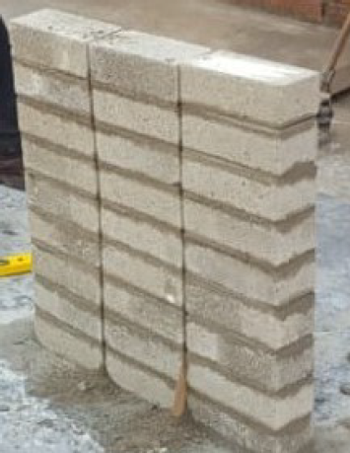 | Step 1 of bond strength test: Three masonry piers
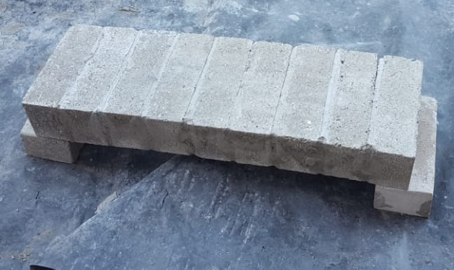 | Step 2 of bond strength test: Masonry pier converted horizontally to act as a beam.
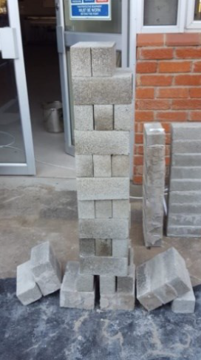 | Step 3 of bond strength test:  Masonry beam being vertically loaded to test bond strength between brick and mortar
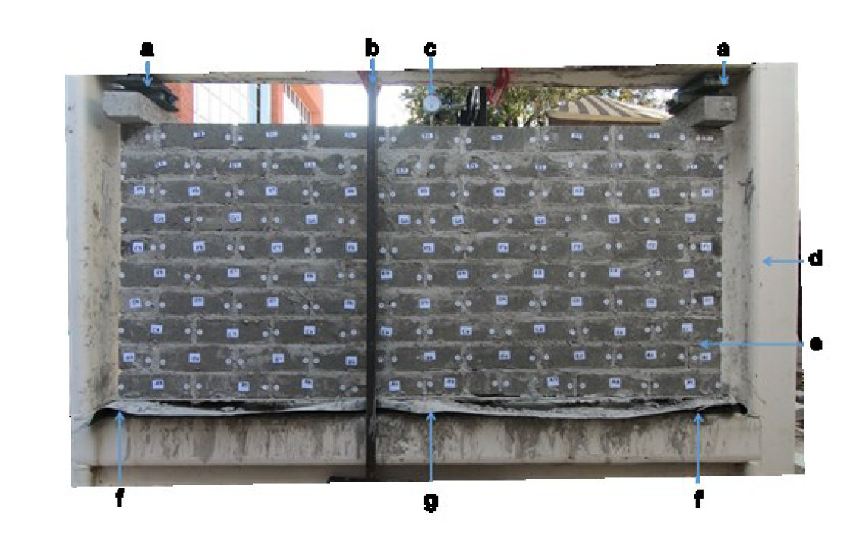 | Constrained Masonry wall panel inside steel frame. The masonry wall panel is prepped for the deformation test.
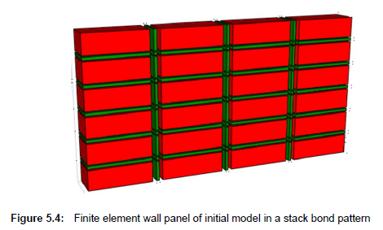 | FE wall panel (initial model)
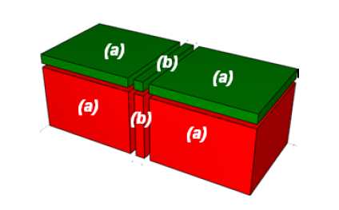 | FEM of brick and mortar upon first division.
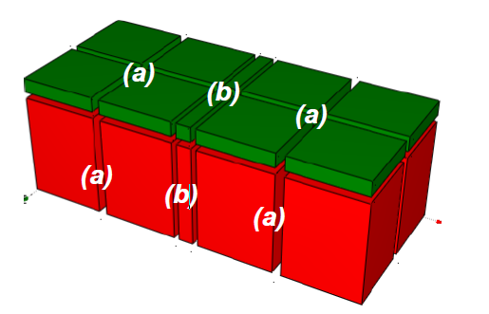 | FEM 2nd division
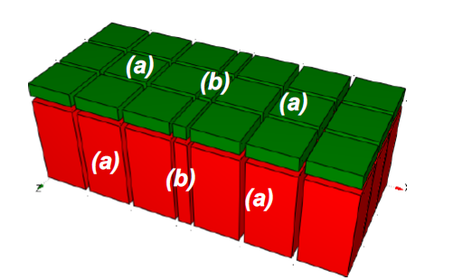 | 3rd division
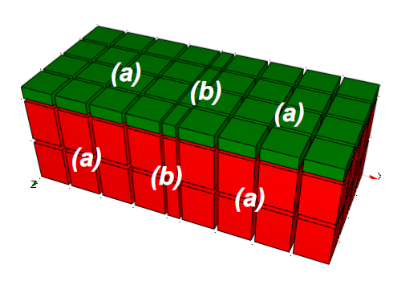 | 4th division
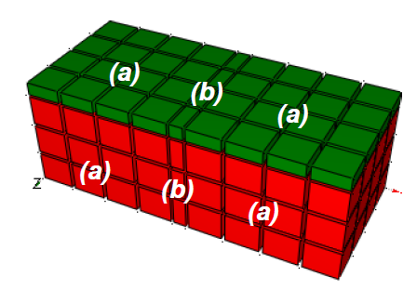 | 5th and final division
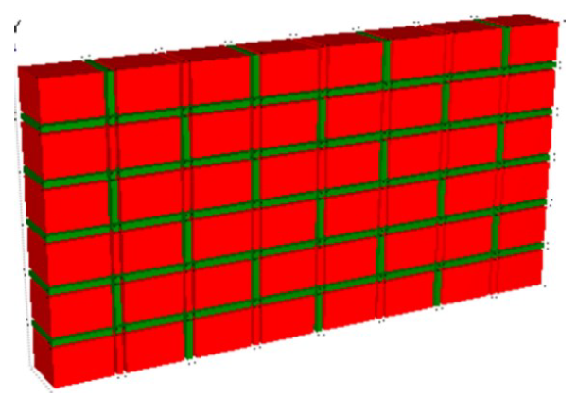 | FE wall panel of 1st division
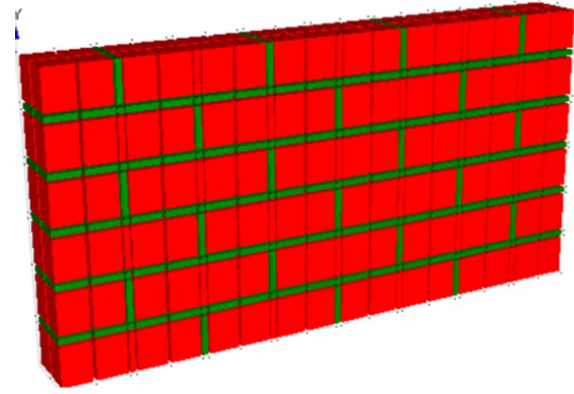 | Wall panel of 2nd division
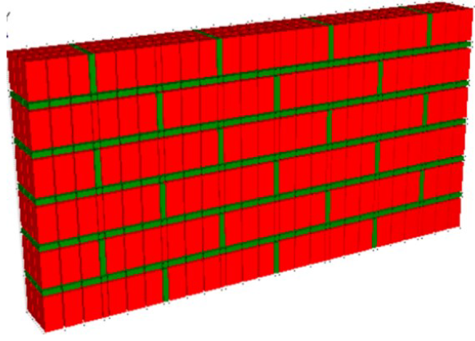 | Wall panel of 3rd division
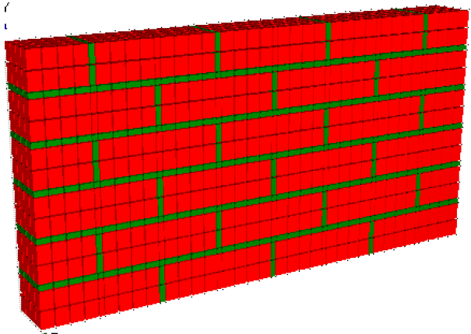 | Wall panel of 4th division
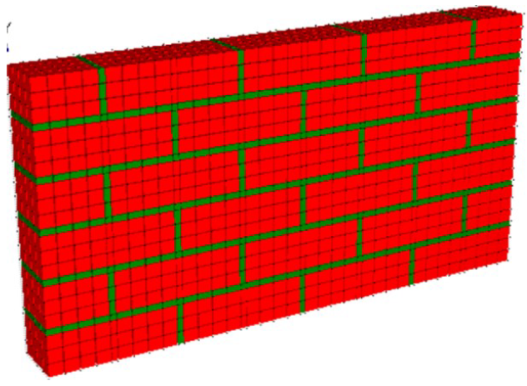 | Wall panel of 5th and final division

Performance of the 6 $×$ 8 finite element wall panel with different mortar material properties
Model Name | SABS no-lime mortar material properties | ASTM K mortar material properties
6 $×$ 8 finite element wall panel with mesh refinement 1 | 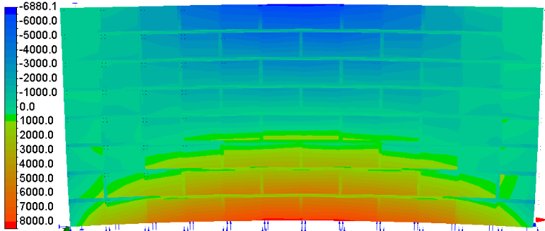 | 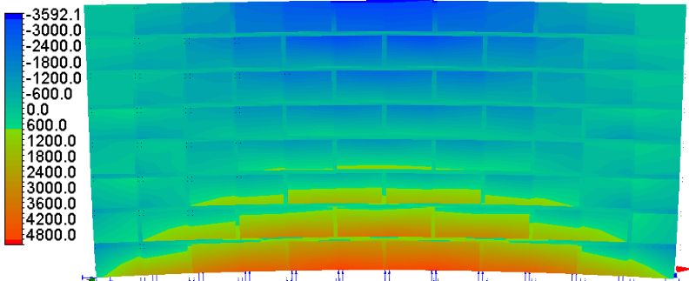
6 $×$ 8 finite element wall panel with mesh refinement 2 | 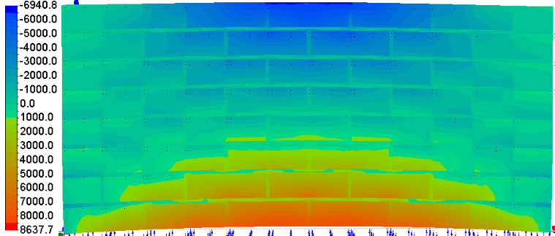 | 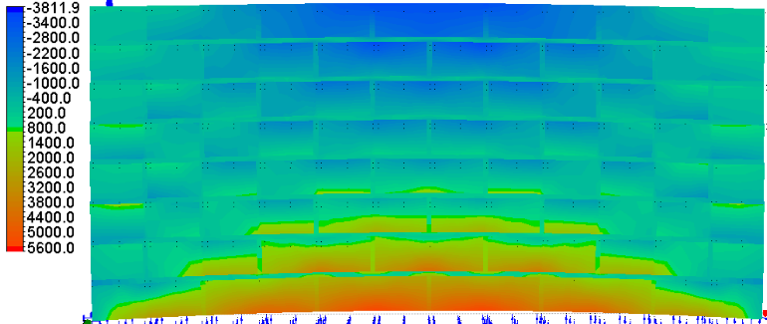
6 $×$ 8 finite element wall panel with mesh refinement 3 | 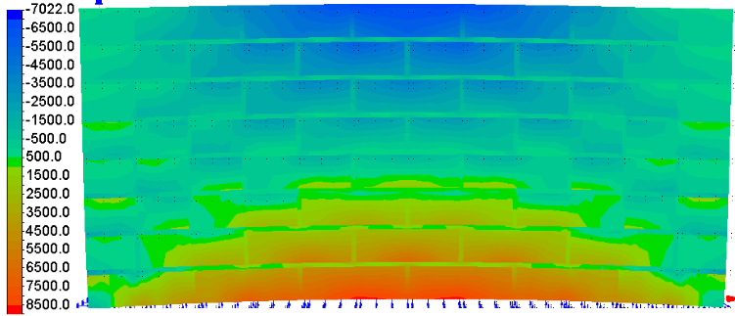 | 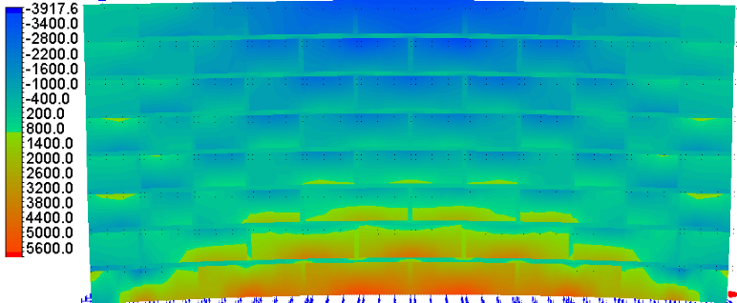
6 $×$ 8 finite element wall panel with mesh refinement 4 | 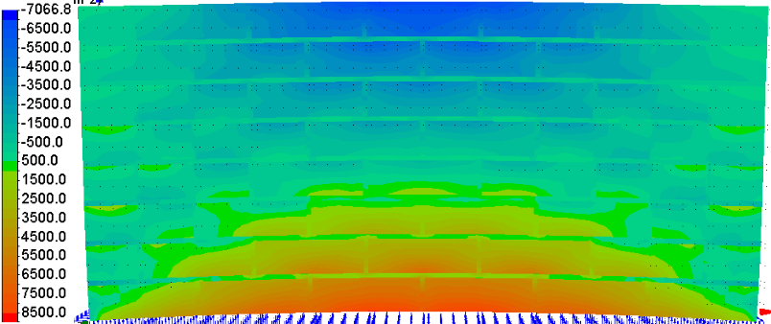 | 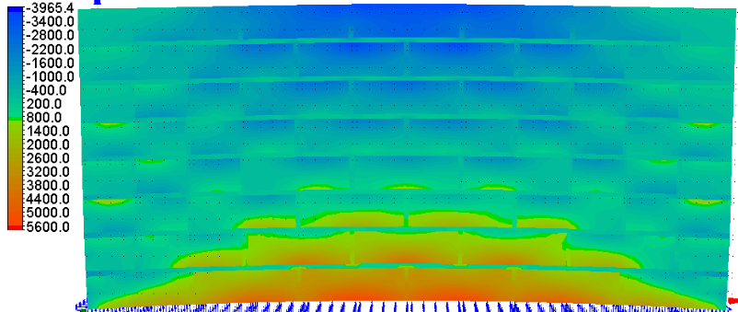
6 $×$ 8 finite element wall panel with mesh refinement 5 | 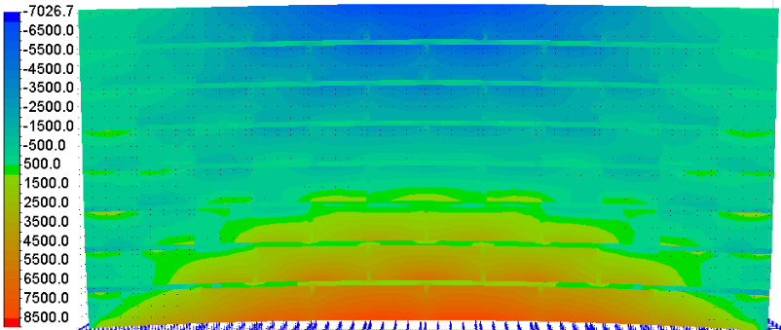 | 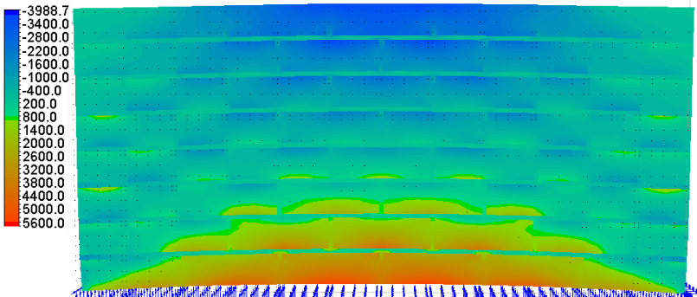

Performance of the 8 $×$ 10 finite element wall panel with two different mortar material properties
Model Name | SABS no-lime mortar material properties | ASTM K mortar material properties
8 $×$ 10 finite element wall panel with mesh refinement 1 | 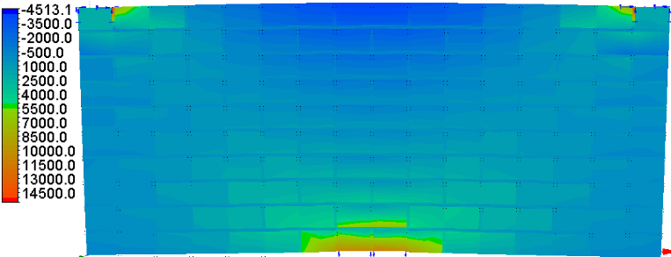 | 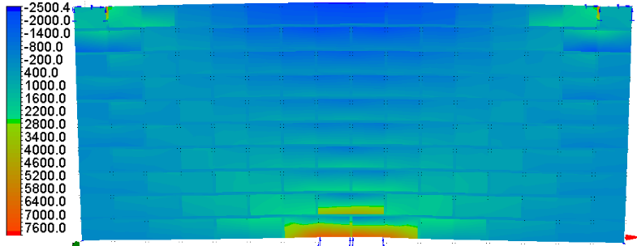
8 $×$ 10 finite element wall panel with mesh refinement 2 | 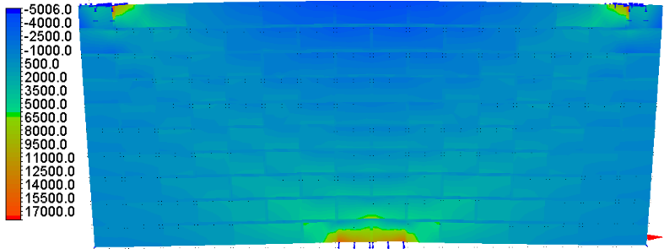 | 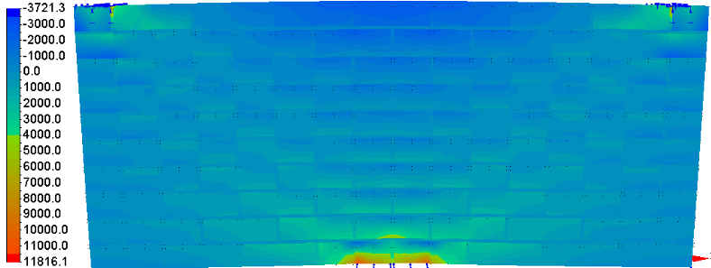
8 $×$ 10 finite element wall panel with mesh refinement 3 | 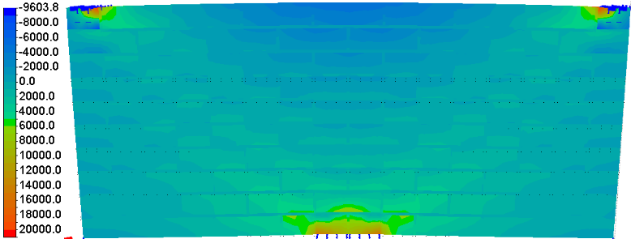 | 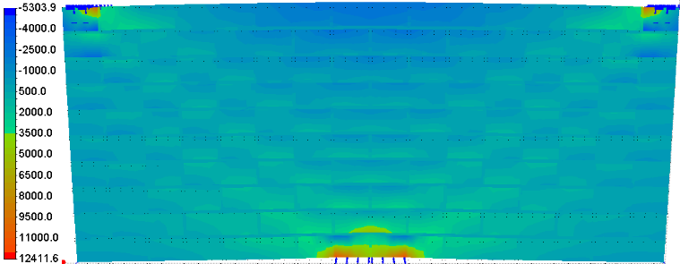
8 $×$ 10 finite element wall panel with mesh refinement 4 | 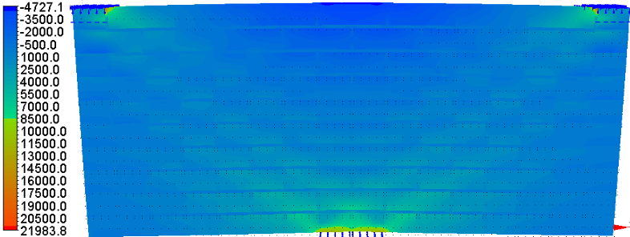 | 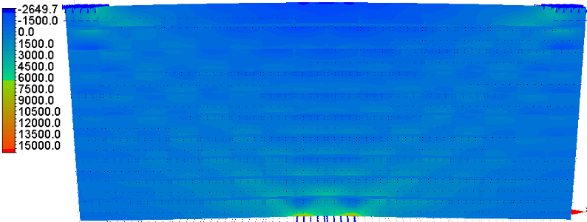
8 $×$ 10 finite element wall panel with mesh refinement 5 | 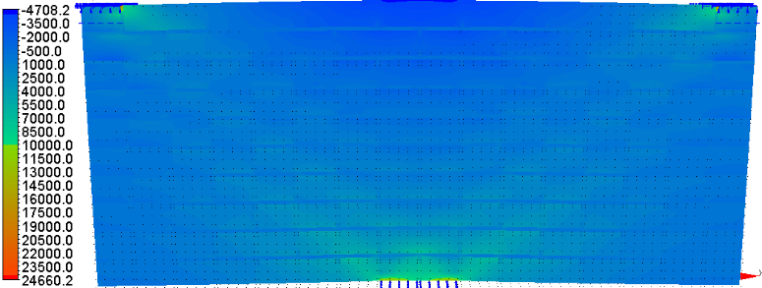 | 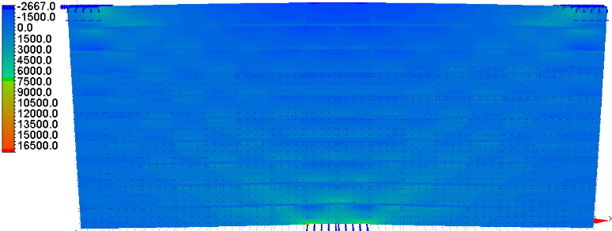

Performance of the M6 and CL90 mortar mixes and standard cement brick material properties in the 8 $×$ 10 finite element wall panel and fifth refinement
Mortar mix | View of performance of material properties
M6  (1:0.5:4) |  | 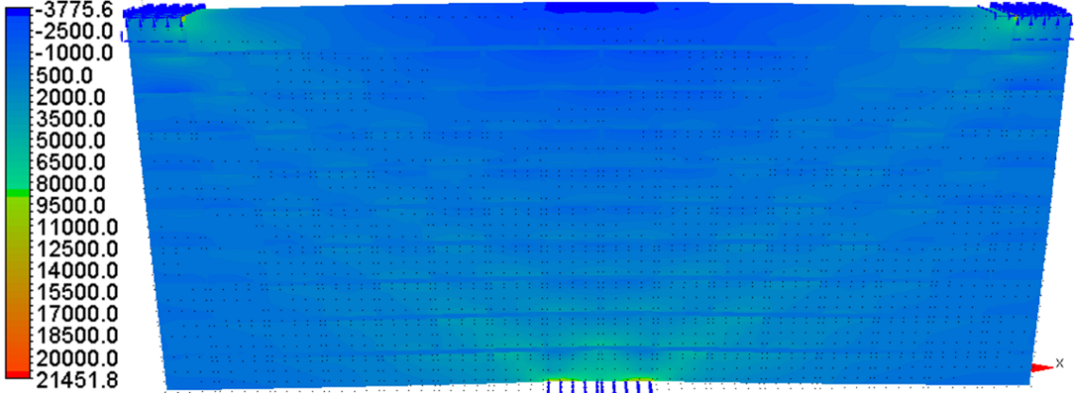
CL90  (0:1:3) |  | 